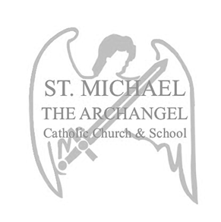
ST. MICHAEL THE ARCHANGEL CATHOLIC CHURCH & SCHOOL
School Fees
academic year 2022-2023

Non-Refundable Registration Fee /Cuota de Inscripción no reembolsable:
$350.00 per student/por estudiante*

*$50 discount will apply to returning families if paid by March 31, 2022/ $50 de descuento se aplicará a las familias que regresen si se paga antes del 31 de marzo de 2022
*$50 discount will apply to new families if school postcard is turned in at Registration/ $50 de descuento se aplicará a las familias nuevas si entregan la tarjeta postal de la escuela en el momento de la inscripción
*Registration fee after June 1, 2022/ La cuota de inscripción después del 1 de junio de 2022: $400 per student/ por estudiante

Annual Tuition per Student /Matrícula anual por Estudiante:
Pre-K 3 Program: $5,300.00
PK4 Program Full Day (with VPK Certificate): $3,300.00
PK4 Program Full Day (no VPK Certificate): $5,300.00
Kindergarten - Grade 3: $8,100.00
Grades 4 - 8: $8,200.00

*Annual tuition will be managed by FACTS Tuition Management. All families are required to enroll with FACTS for tuition payments. A yearly enrollment fee of $41 will be payable to FACTS / La matrícula anual será administrada por FACTS Tuition Management. Todas las familias deben inscribirse con FACTS para los pagos de matrícula. Se pagará una cuota de inscripción anual de $41 a FACTS
*Payments will be divided in 10 months- August 2022- May 2023/ Pagos se dividen en 10 meses- Agosto 2022 a Mayo 2023
*Applications for financial assistance must be made through FACTS Financial Aid/ Las solicitudes de asistencia financiera deben realizarse a través de FACTS Financial Aid

