2nd Grade Summer Reading
2024-2025

Dear Second Grade Parents,
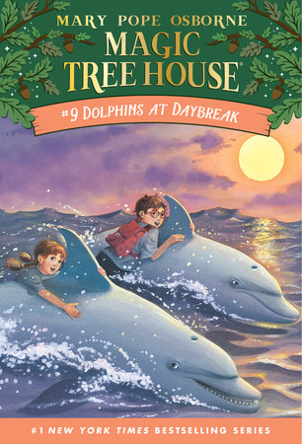
During the summer, the students will be required to read the following book, Magic Tree House: Dolphins at Daybreak by: Mary Pope Osborne. The story is about Jack and Annie and their magic tree house whisking them off to the middle of the ocean! Luckily, they find a mini submarine on a coral reef. Unluckily, they are about to meet a giant octopus and one very hungry shark. Will the dolphins save the day? Or are Jack and Annie doomed to be dinner? It’s a wonderful book and I can’t wait to discuss it with your children! When students arrive back to school, we will review what they have read, and create a book report together in class. I hope you all have a wonderful summer and see you next year!

Your 2nd grade teacher

